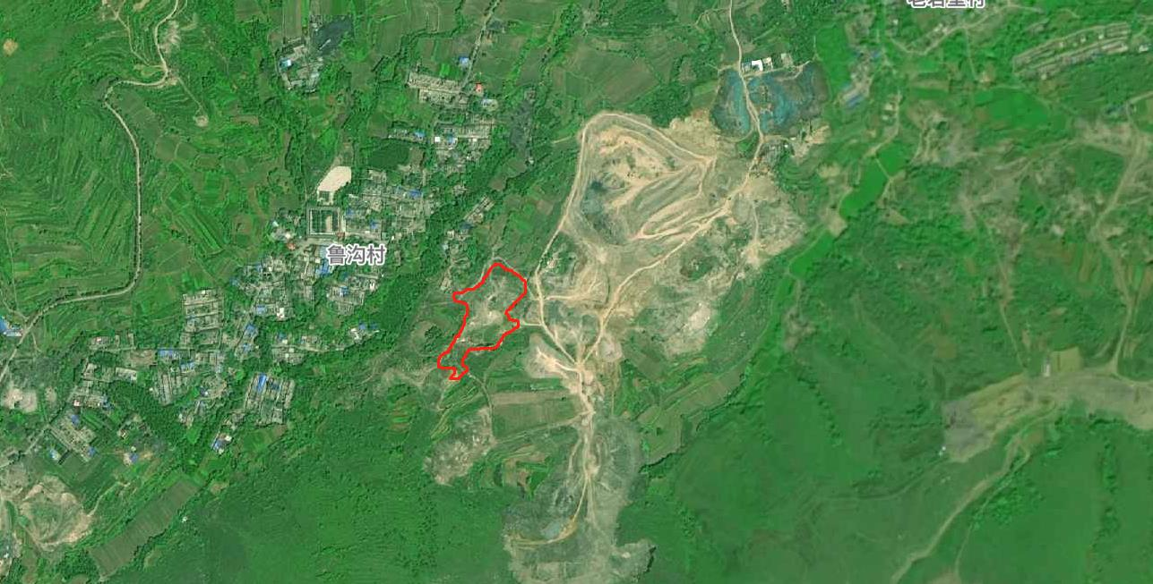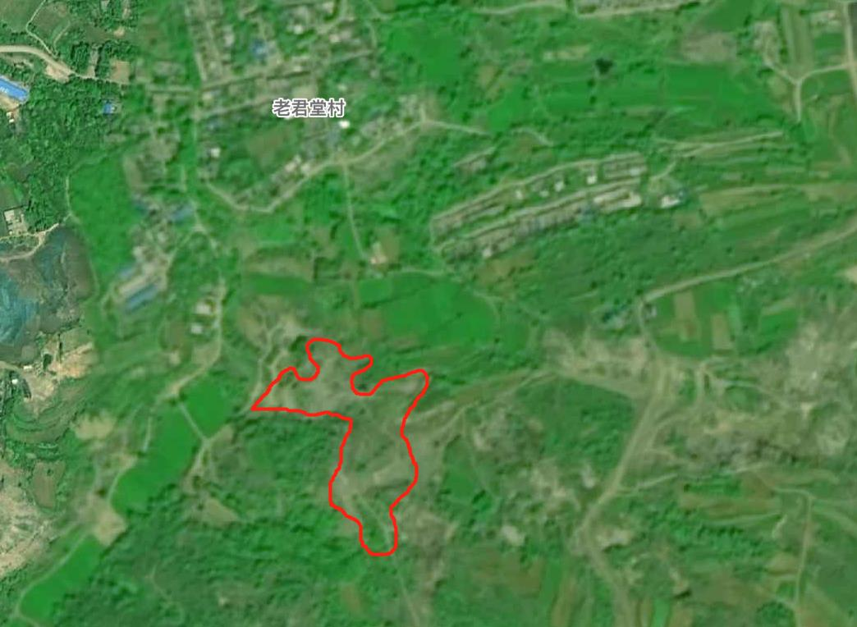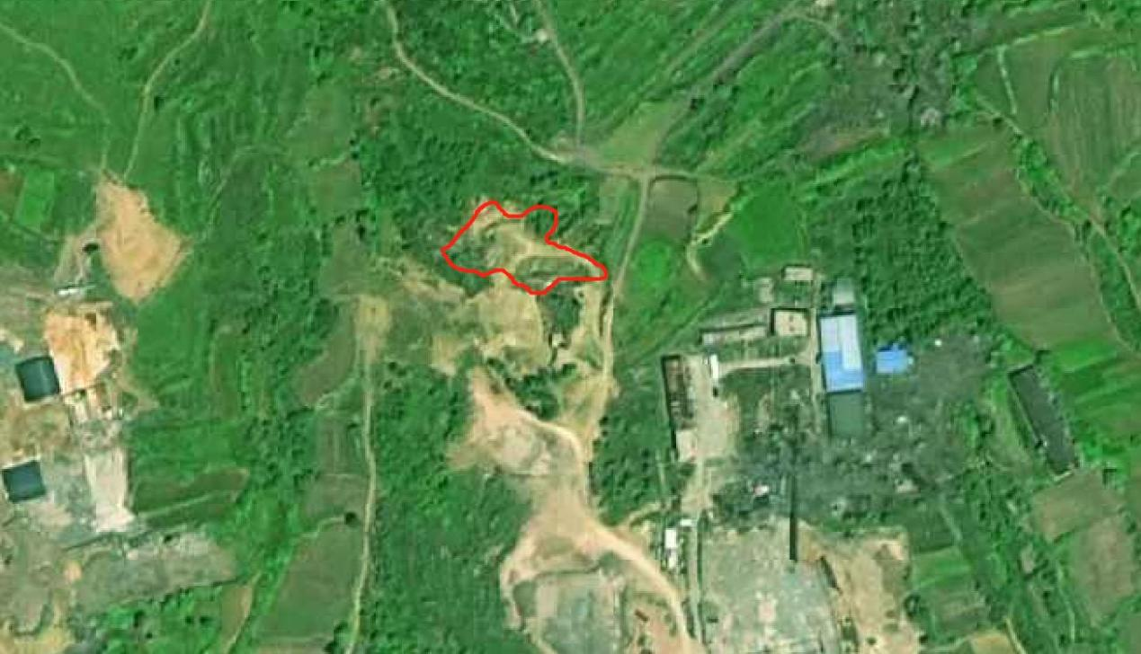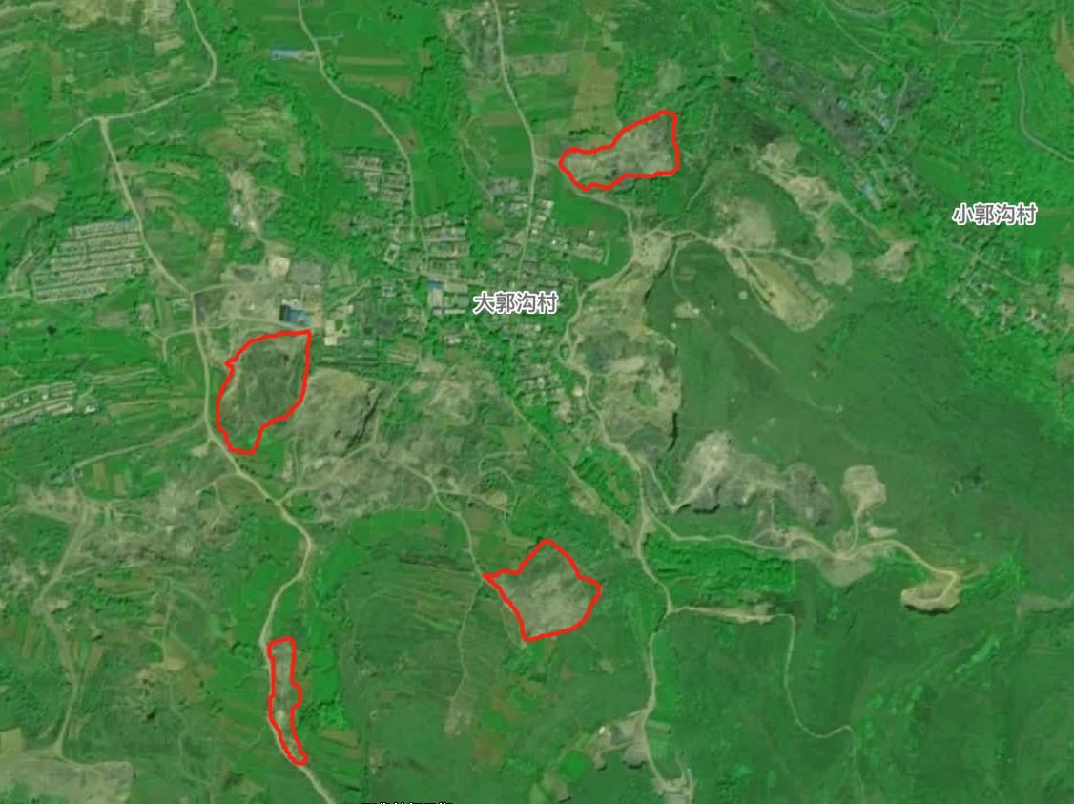

ZJ4103292021014002

ZJ4103292021014001

ZJ4103292021014003

ZJ4103292021015002

ZJ4103292021015003

ZJ4103292021015004

ZJ4103292021015001